PRACTICAL 4 : Temperature Detector

Aim : To measure and display temperature using a temperature sensor with Arduino.

Overview :
This project uses a temperature sensor to measure environmental temperature and display it on a serial monitor or other output devices. It introduces sensor interfacing with Arduino and provides a fundamental understanding of analog-to-digital conversion in IoT applications.

Materials Required :
- Arduino Uno R3
- Temperature Sensor (TMP36)
- Pushbutton
- Slide Switch
- Peizo
- Jumper Wires
- Arduino IDE (Installed on your Computer)

Circuit Connection and Steps :
- Connect the Temperature Sensor (TMP36) :
  - VCC (left pin) → 5V
  - GND (right pin) → GND
  - VOUT (middle pin) → Analog Pin A5
- Connect the Buzzer and Pushbutton:
  - Buzzer: Positive (+) to Digital Pin 11, Negative (-) to GND
  - Pushbutton: One terminal to Digital Pin 6, the other to GND
- Set Up the Arduino Environment :
  - Open Arduino IDE, select the correct board and port & upload the code.

Circuit Diagram :
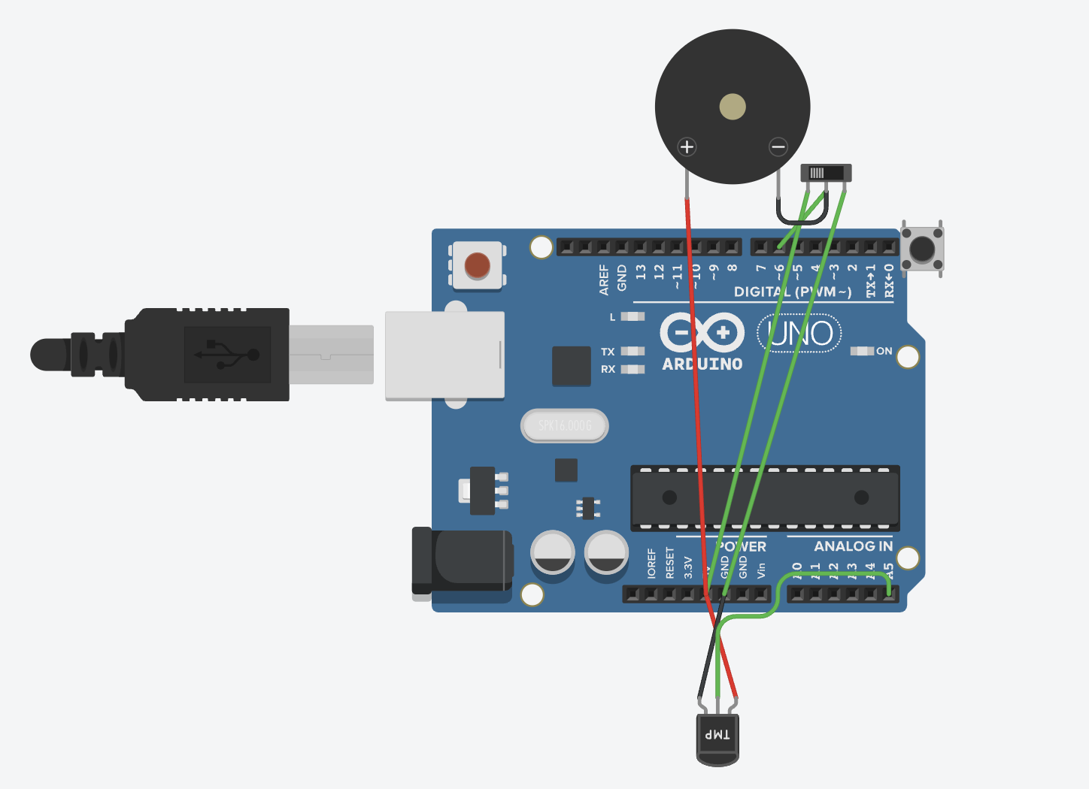
Schematic Diagram :
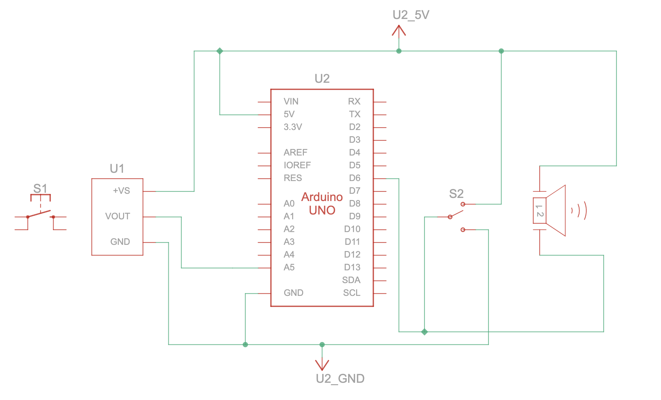

Code :
// C++
// Define the pin connections for the components

int tempSensorPin = A5; // Pin connected to the temperature sensor
int buttonPin = 6; // Button to activate temperature reading
int ledPin = LED_BUILTIN; // Built-in LED for indication

int TMP = 0; // Variable for Fahrenheit temperature
int Celcius = 0; // Variable for Celsius temperature

// Setup function runs once when the program starts
void setup() {
pinMode(ledPin, OUTPUT); // Set LED as OUTPUT
pinMode(buttonPin, INPUT); // Set button as INPUT
pinMode(tempSensorPin, INPUT); // Set temperature sensor as INPUT
Serial.begin(9600); // Start serial communication
}

// Loop function runs repeatedly
void loop() {
// Blink LED to show system is running
digitalWrite(ledPin, HIGH);
delay(100); // Wait for 100 milliseconds
digitalWrite(ledPin, LOW);
delay(100); // Wait for 100 milliseconds

// Check if the button is pressed
if (digitalRead(buttonPin) == LOW) {
// Read temperature and convert
TMP = (-40 + 0.878679 * (analogRead(tempSensorPin) - 20)); // Fahrenheit
Celcius = (-40 + 0.488155 * (analogRead(tempSensorPin) - 20)); // Celsius

// Print temperature readings to Serial Monitor
Serial.print("--> Temperature: ");
Serial.print(TMP);
Serial.println("°F");

Serial.print("--> Temperature: ");
Serial.print(Celcius);
Serial.println("°C\n");
}
}

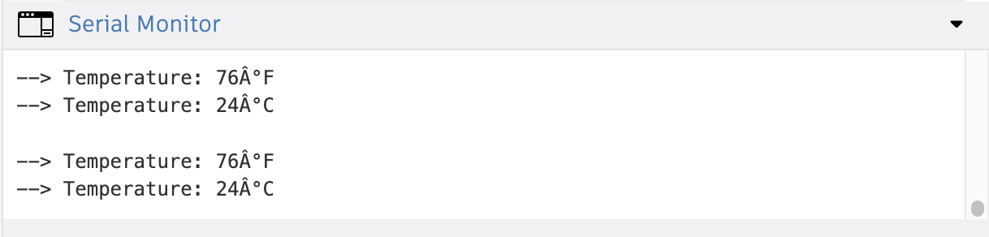
Results :
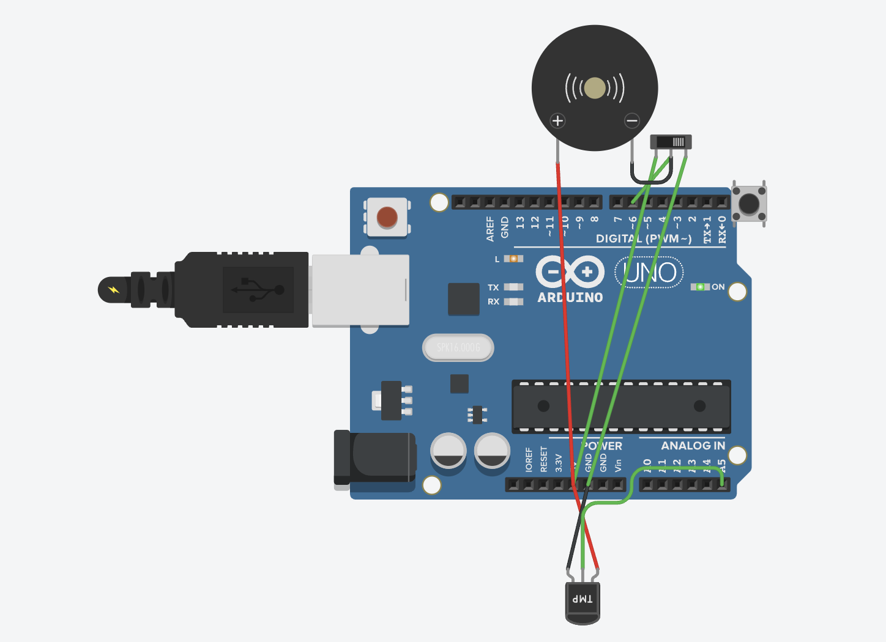

Conclusion :
The Temperature Detector project successfully measures and displays temperature readings using a sensor and Arduino. It introduces the fundamental concept of sensor interfacing and data acquisition. This project serves as a foundation for more advanced IoT applications in environmental monitoring and smart home systems.

